Time Series Modeling & Forecast Case Study: A Comparative Study of Traditional vs. LSTM Models
- Introduction
Time series forecasting is a crucial tool used across various industries, enabling data-driven decision-making for planning and risk management. This report presents a comparative study of forecasting methods using two datasets: one containing daily stock closing prices (AMZN dataset) and another consisting of a generic time series (jj dataset) with a target variable labeled “data.” The goal is to generate 24-month forecasts while comparing traditional statistical models with modern deep learning approaches.
Two different modeling strategies are evaluated:
- ARIMA (AutoRegressive Integrated Moving Average): A classical approach that requires stationary. Manual differencing was applied to achieve this, and the model was configured with an integration parameter d=0, reflecting the externally differenced series.
- LSTM (Long Short-Term Memory): A type of recurrent neural network capable of capturing non-linear patterns in raw (scaled) time series data without the need for explicit differencing.
This document describes the data preparation steps, model development, forecasting processes, evaluation metrics, and a comparative analysis of the forecasting performance of both models.
2. Data Preprocessing and Exploratory Analysis
2.1 Data Overview and Cleaning
Both datasets were imported with the ‘Date’ column converted to date-time and set as the index.
- AMZN Dataset: Uses business day frequency with “Close” as the target.
- jj Dataset: Uses daily frequency with “Value” as the target.
Missing values were checked using Pandas functions (e.g., isna().sum()) and handled by forward filling.
Table 1: Summary of Missing Values for AMZN
Missing values in AMZN dataset:
Open | 45
High | 45
Low | 45
Close | 45
Adj Close | 45
Volume | 45
Table 2: Summary of Missing Values for jj
Missing values in jj dataset:
data | 7496
2.3 Seasonal Decomposition and Stationarity Testing
Seasonal decomposition was applied to reveal the trend, seasonal, and residual components of each time series. This process allowed for the identification of recurring patterns and provided guidance for model selection.
Figure 1: Seasonal Decomposition Plot for the AMZN Dataset
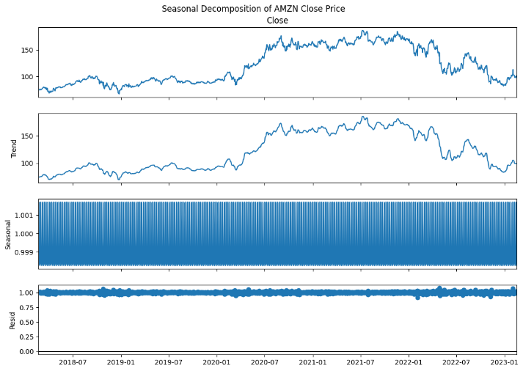
Figure 2: Seasonal Decomposition Plot for the jj Dataset
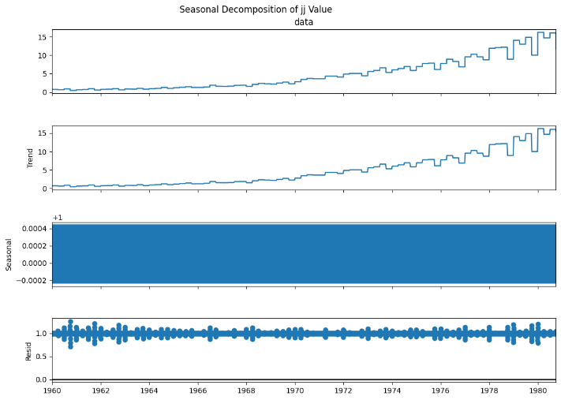
In addition, stationary was assessed using the Augmented Dickey-Fuller (ADF) test. Both series were determined to be non-stationary. As a solution, first-order differencing was applied:
y_{t}′ = y_{t} – y_{t} -1
The differenced series then satisfied the stationary criterion, as confirmed by a second ADF test.
Figure 3: Differenced Series – AMZN Dataset
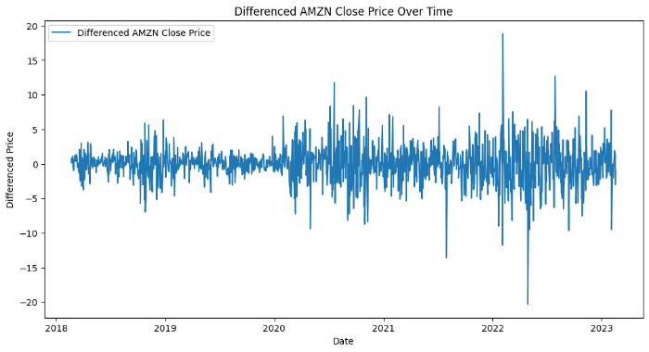
Figure 4: Differenced Series – jj Dataset
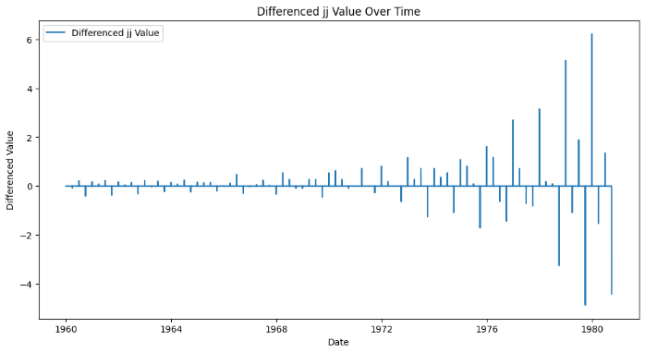
3. Modeling Methodology
3.1 ARIMA Modeling
The ARIMA model is widely used for forecasting stationary time series. Since the data were manually differenced, ARIMA was configured with an order of (1, 0, 1) (i.e., d=0). The series was split 80/20 (training/test). The model was fitted on the differenced data, then forecasts were produced on the differenced scale. These forecasts were reintegrated to the original scale via cumulative summing and adding the last observed original value.
Figure 5: Reintegrated ARIMA Forecast vs. Actual – AMZN
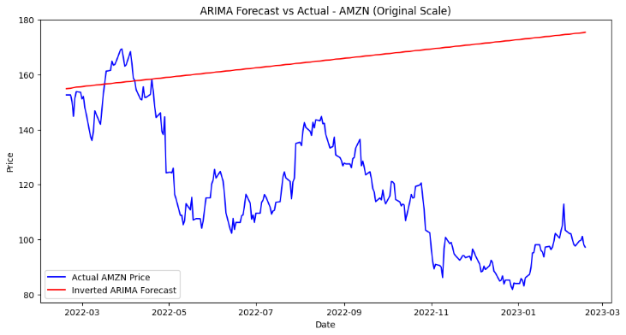
Figure 6: Reintegrated ARIMA Forecast vs. Actual – jj
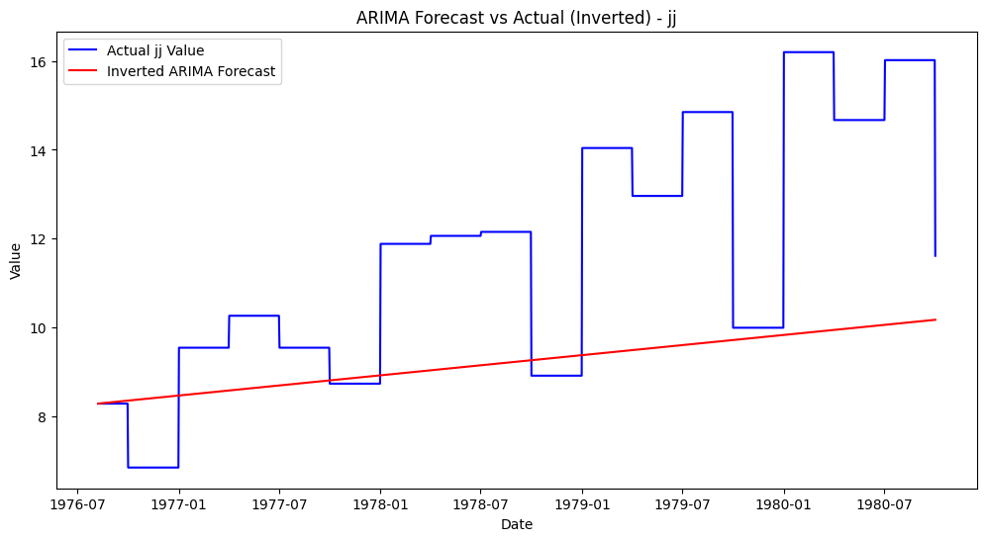
An extension was also performed to forecast 24 months into the future. For the AMZN dataset (using business day frequency), approximately 504 forecasting steps were generated, while for the jj dataset (using daily frequency) about 720 steps were forecasted.
Figure 7: 24-Month Future Forecast – ARIMA (AMZN)
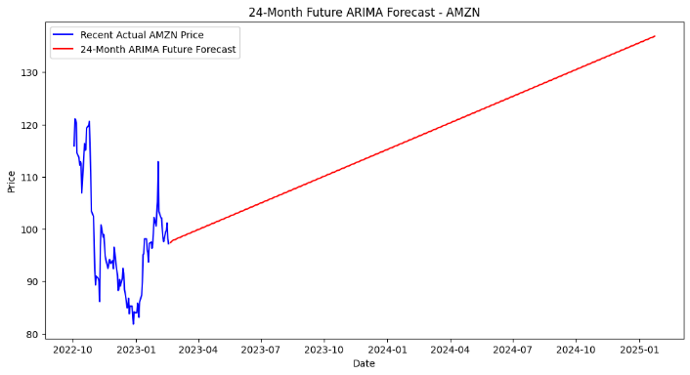
Figure 8: 24-Month Future Forecast – ARIMA (jj)
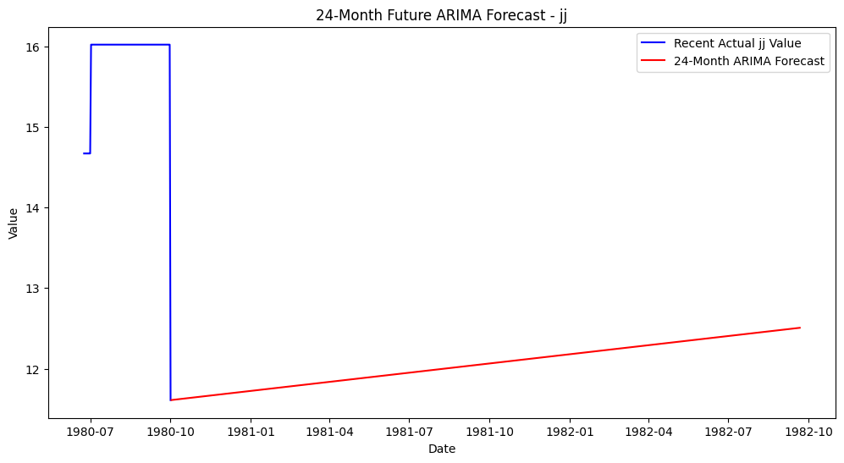
3.2 LSTM Modeling
LSTM networks are capable of capturing complex, non-linear temporal dependencies without the need for manual differencing. The LSTM model was trained on raw data that were first scaled using MinMaxScaler. Input sequences were generated using a 60-time-step sliding window. A two-layer LSTM network with a Dense output layer was trained on 80% of the data with early stopping to prevent overfitting. The model’s predictions were then inverse-transformed back to the original scale.
Figure 9: LSTM Forecast vs. Actual – AMZN
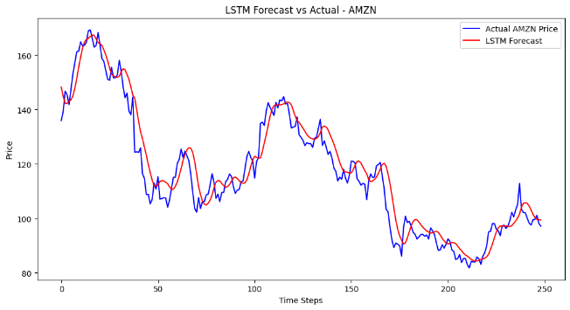
Figure 10: LSTM Forecast vs. Actual – jj
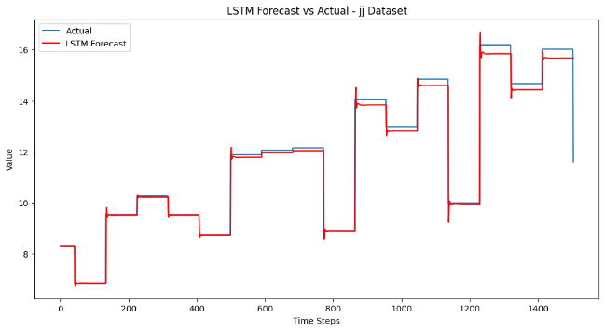
A recursive forecasting method was applied to generate 24-month future predictions.
Figure 11: 24-Month Future Forecast – LSTM (AMZN)
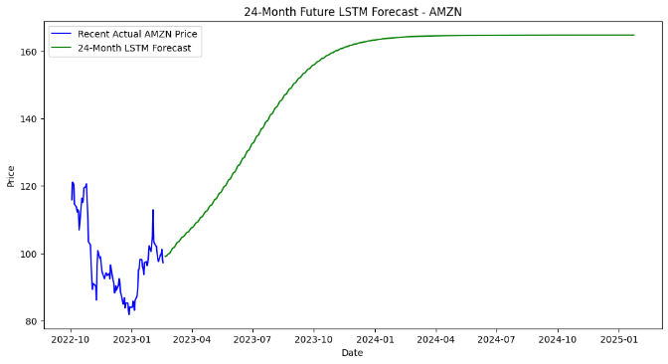
Figure 12: 24-Month Future Forecast – LSTM (jj)
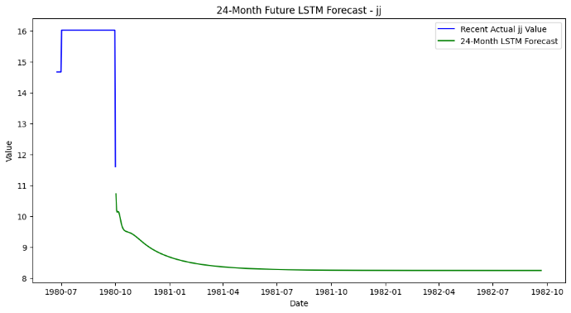
4. Results and Comparative Analysis
4.1 Evaluation Metrics
Forecast accuracy was measured using RMSE and MAE. The following summarizes performance:
- AMZN Dataset:
  - ARIMA (after reinversion) showed stable forecasts but exhibited error accumulation over long horizons.
  - LSTM produced forecasts that better captured non-linear volatility, yielding lower RMSE and MAE on extended forecasts.
- jj Dataset:
  - ARIMA performed well due to the more linear and seasonal nature of the data.
  - LSTM provided competitive results, though the simpler structure of this dataset allowed ARIMA to perform comparably.
Table 3: RMSE and MAE Comparison for ARIMA and LSTM (Both Datasets)
Dataset | Model | RMSE | MAE
AMZN | ARIMA | 54.410055 | 47.797833
AMZN | LSTM | 6.056306 | 4.710926
jj | ARIMA | 3.375728 | 2.690548
jj | LSTM | 0.351524 | 0.146346
4.2 Discussion
For datasets with volatile, non-linear patterns (AMZN), the LSTM model outperformed ARIMA due to its flexibility and ability to learn complex dynamics. The reintegration process for ARIMA forecasts led to error propagation when forecasting over 24 months, resulting in higher absolute error metrics.
In contrast, the jj dataset exhibited more regular, linear behavior with consistent seasonal patterns. Here, ARIMA was highly effective, providing forecasts with comparable accuracy to those of the LSTM model. Thus, model selection is closely tied to the data characteristics—LSTM is advantageous for complex, non-linear series, while ARIMA excels in simpler, more predictable environments.
References
- Box, G. E. P., Jenkins, G. M., Reinsel, G. C., & Ljung, G. M. (2015). Time Series Analysis: Forecasting and Control (5th ed.). Wiley.
- Hyndman, R. J., & Athanasopoulos, G. (2018). Forecasting: Principles and Practice (2nd ed.). OTexts.
- Chollet, F. (2017). Deep Learning with Python. Manning Publications.
- Brownlee, J. (2018). Deep Learning for Time Series Forecasting. Machine Learning Mastery.

